Big Apple Academy 2018 Mathematics Department
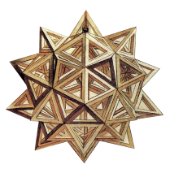

Grade 5 6 Summer Homework Math Package
It is important that you keep practicing your mathematical Knowledge over the summer to be ready for 6th grade. In this Package you will find a calendar of activities for the month of July and August.
What should you do?
- Take a new notebook for every-day practice. For each day you will need 2 pages;
- Start each day with vocabulary words: copy each word from the given day-list, find and write the meaning of each word in your notebook on the front page (pages 1,3,5, . . . and so on):
www.amathsdictionaryforkids.com/dictionary.html
- Use the internet to find the meaning of each word you do not know;
- Solve the problem of the day and write the solution with full explanation on the back page (pages 2,4,6,. . . and so on);
- Have the date of the entry. Have a clear and complete answer. Be neat and organize.
Do not forget to bring your notebook to school on September 4, 2018 - the first school day.

Have a Great Summer!!
Big Apple Academy Mathematics Department
July_  5 6  Monday | Tuesday | Wednesday | Thursday | Variable  Expression  Equation  Properties of equality  Friday 29 | Decimal  Negative power of ten  Saturday 30 | Incoming  6th Grade
Scientific notation  2 | Divisibility  Divisibility rules  3 | Prime and composite numbers  4 | Prime factorization  GCF  LCM  5 | Equivalent fractions  LCD  Simplest form  6 | like denominators  unlike denominators  7 | Summer Home Work VOCABULARY
Mixed numbers  Improper fraction  9 | Reciprocal  Multiplicative inverse  10 | Ratio  Equal ratios  Rate  Unit rate  11 | Proportion  Cross product  12 | Scale drawing  Scale  13 | Percent  14
Convert percent to fraction and decimal  Convert fraction and decimal to percent 16 | Percent of a number  17 | Sales tax  Total cost  18 | Discount  Sale price  19 | Increase  Decrease  20 | Principal  Interest  Simple interest  21
Commission  Rate of commission  23 | Opposites  Integers  Absolute value  24 | Rational numbers  25 | Exponential form  base  exponent  expanded form  26 | Round  Estimate  Clustering  27 | Order of operations  Properties of operations  28

Big Apple Academy Mathematics Department
July_  5 6  Monday | .  Tuesday | Wednesday | Thursday | Decide if the solution is correct.  12n – 5 = 4n + 35  n = 4  Friday 29 | In the number 44.444 which digit has 1/10 the value of the 4 in the hundredth place?  Saturday 30 | Incoming  6th Grade
Write 0.00000678  in scientific notation.  2 | I am a 3-digit number less than 300. I am divisible by 2 and 5, but not 3. The sum of my digits is 7. What number am I? 3 | The number 59 and I are the only two prime numbers between 50 and 60.Who am I?  4 | I am the least common multiple of two numbers whose sum is 20. One number is 4 greater than the other. What number am I? 5 | Use two prime numbers to create a fraction that is equivalent to $\frac{21}{49}$.  6 | One-half of a number added to one-fourth of 96 is 30. What is the number?  7 | Summer Home Work for FUN
4$\frac{5}{12}$ - 2$\frac{9}{16}$  9 | $$\frac{2-\frac{3}{4}}{6\frac{1}{4}+ \frac{1}{2}}$$  10 | Which is the better buy: One gallon of milk for $1.99, or $\frac{1}{2}$ gallon of milk for $0.98?  11 | Ruth’s batting average was 400 after 60 bats. After 20 more bats she lifted her average to 500. How many hits she get in those 20 bats?  12 | Tina wants to enlarge this old photograph of her parents for their anniversary. If the scale is 1 inch = 2,5 inches, what will the dimen-sions of the final photo be?  13 | I am a three-place decimal that is equivalent to the difference between 1 and$\frac{3}{8}$. What decimal am I ?  14
Write $\frac{2}{5}$% as a fraction and decimal  16 | What is 20% of $\frac{2}{5}$  of 15  17 | A rug cost $296 plus 6$\frac{1}{2}$% sales tax. Find the sales tax and the total cost.  18 | After a discount of 15%, the price of a shirt is $51. What was the original price of the shirt?  19 | After 2 month on a diet, John’s weight dropped from 168 to 147 pounds. By what percent did John’s weight drop? 20 | Find the amount of interest and the total amount. $250 for 2 years at simple interest rate of 7.5% per year. 21
Amount sold for $4,500. Rate of commissions 2.5%  Commission?  23 | Compare  |-6| and -6  24 | Order from greatest to least  -2.4, $\frac{5}{8}$, - $\frac{5}{8}$, 0  25 | Write 78,045 in expanded form using exponents  26 | The sum of my digits is 11. When rounded to the nearest hundred, I am 500. Rounding to the nearest ten makes me 530. What number am I? 27 | Evaluate the expression  2{ 5[12 + 5(500 - 100) + 99]}  28 | 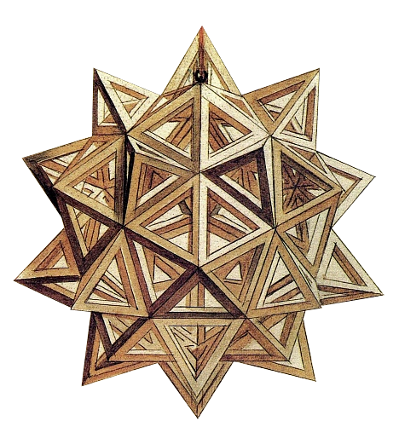

Big Apple Academy Mathematics Department
August-  5 6  Average  Monday 30 | Permutations  Combinations  Tuesday 31 | Probability  Wednesday 1 | Operations with integers  Thursday 2 | Equation  Friday 3 | expression  Saturday 4 | Incoming  6th Grade
Exponent  Base  Power  6 | Order of operation  7 | Coordinate plane  Ordered pair  Quadrant  Origin  8 | Relation  Function  9 | t-table  linear equation  10 | Angle  Acute angle  Obtuse angle  Right angle  Straight angle  11 | Summer Home Work VOCABULARY
Complementary angles  Supplementary angles  13 | Reflex angle  14 | Triangle  Classify the triangles by sides and angles  15 | Sum of all angles of a triangle  16 | Perimeter  Square  Rectangle  17 | Area  Rectangle  Perimeter  18
trapezoid  parallelogram  rhombus  square  rectangle  20 | Similar triangles  Corresponding sides  21 | Perimeter  Area  22 | Parallelogram  Area  Perimeter  23 | Surface area  Area of a square  24 | Circle  Radius  diameter  Circumference  25
Area of a circle  27 | Volume  Rectangular prism  Base  Height  28 | Mean  Median  Mode  Range  29 | Review  30

Big Apple Academy Mathematics Department
August-  5 6  3² + (–5)² – (–1)³ = ?  Monday 30 | Marcy’s average score on four tests was 84. Three of scores were 84, 88, and 80. What was the fourth score?  Tuesday 31 | Eight children line up at the water fountain. Find the number of possible arrangements.  Wednesday 1 | Find the probability of getting a sum of 5 or a sum of 7 when two cubes are tossed.  Thursday 2 | Solve  x + (–21) = –59  Friday 3 | Evaluate  x – (–2)  for x = 3  Saturday 4 | Incoming  6th Grade
Compare  –7² and (–7)²  6 | $$\frac{{-5}^{2}+{(-5)}^{2}}{\left|4^{2}- 2^{5}\right|-(-3)}$$  7 | Draw a coordinate plane. Graph and label the points given.  (0,5), (–3,1), (–1,0) (–4, –5)  8 | Tell whether relation is a function  a 1 6 9 1  b 3 -1 -1 3  9 | Make a T-table. Then graph each equation.  Y = -3  Y = – x –3  X = – 4  10 | From midnight to noon, the hands of a clock form straight angles several times. How many times?  11 | Summer Home Work for FUN
Find the complement and supplement of 56° angle.  13 | Draw a 255° angle.  14 | Is it possible to make an equilateral obtuse triangle? Explain.  15 | Find the third angle of a triangle, given that the first two angles are 55° and 70°. What kind of triangle is it?  16 | Find the area of the square which has the same perimeter as a rectangle 12 by 2.  17 | What is the greatest area of a rectangle with a perimeter of 50?  18
True or false.  All trapezoids are parallelograms.  Every square is a rhombus.  Every rectangle is a square.  20 | 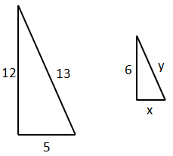  x =  y =  21 | 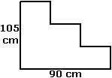  Find the perimeter and the area.  22 | 15cm  10 cm  20cm  Area = ?  Perimeter = ?  23 | Find the surface area of a cube with edge of 3.2 meters.  24 | If circumference of a Ferris wheel is 134 meters, what is its diameter? Use 3.14 for π.  25
What is the area of a circular garden with a diameter of 4 feet?  27 | An aquarium has a rectangular base 36 in by 12 in. its volume is 6912 in³. Find its height.  28 | Find the mean, median, mode and range of a data set.  1.8, 1.95, 1.85, 1.8, 1.6  29 | Check everything you solved and prepare your questions for teacher.  30

