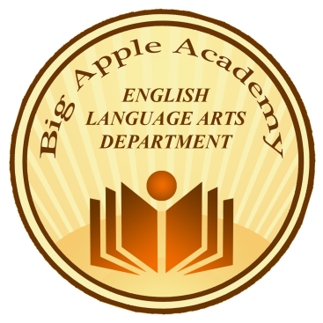
Where excellence becomes tradition
2937 86th Street, Brooklyn, NY 11229, Tel. (718) 333-0300

“TV. If kids are entertained by two letters, imagine the fun they'll have with twenty-six. Open your child's imagination. Open a book.” ~Author Unknown

Dear Parents,

As you know, the summer months are fast approaching, and while we all look forward to the warm, relaxing summer days, we need to ensure that our students will do their very best to retain the reading skills they acquired in the course of this school year.
To ensure a smooth transition into the next school year, your child will be required to read FOUR BOOKS over the course of the summer. Please note that upon returning to school in September, your child’s reading will be assessed. The reading exam will be mostly comprised of short, written responses based on the reading of ONE of the assigned summer reading books. The summer assessment results will additionally help the English teachers to gauge how well your child read over the summer months.
Therefore, it is essential that you continue to encourage your child to read over the summer. Attached to this letter, you will find the list of the required summer reading.
Have a wonderful summer!
Happy Readings!

Dina Kuzminer
Chairperson, Department of English Language Arts
Big Apple Academy

Summer Reading List for Students Entering Grade 7

- The Last Book in the Universe by Rodman Philbrick

- The Thief by Meghan Whalen Turner

- The Westing Game by Ellen Raskin

- And Then There Were None by Agatha Christie

