Big Apple Academy 2020 Mathematics Department
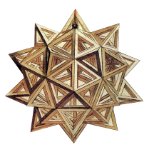

Summer Math Homework Package Grade 5 6
It is important that you keep practicing your mathematical Knowledge over the summer to be ready for 6th grade. In this Package you will find a calendar of activities for the month of July and August.
What should you do?
- Take a new notebook for every-day practice. For each day you will need 2 pages;
- Start each day with vocabulary words: copy each word from the given day-list, find and write the meaning of each word in your notebook on the front page (pages 1,3,5, . . . and so on):
https://dynamiclearningmaps.org/sites/default/files/documents/ERP/dlm_math_glossary.pdf

- Use the internet to find the meaning of each word you do not know;
- Solve the problem of the day and write the solution with full explanation on the back page (pages 2,4,6,. . . and so on);
- Have the date of the entry. Have a clear and complete answer. Be neat and organize.
Do not forget to bring your notebook to school on the first school day.

Have a Great Summer!!

Big Apple Academy Mathematics Department
July_  5 6  Monday | Tuesday | Wednesday | Thursday | Variable  Expression  Equation  Properties of equality  Friday 26 | Decimal  Negative power of ten  Saturday 27 | Incoming  6th Grade
Scientific notation  29 | Divisibility  Divisibility rules  30 | Prime and composite numbers  1 | Prime factorization  GCF  LCM  2 | Equivalent fractions  LCD  Simplest form  3 | like denominators  unlike denominators  4 | Summer Home Work VOCABULARY
Mixed numbers  Improper fraction  6 | Reciprocal  Multiplicative inverse  7 | Ratio  Equal ratios  Rate  Unit rate  8 | Proportion  Cross product  9 | Scale drawing  Scale  10 | Percent  11
Convert percent to fraction and decimal  Convert fraction and decimal to percent 13 | Percent of a number  14 | Sales tax  Total cost  15 | Discount  Sale price  16 | Increase  Decrease  17 | Principal  Interest  Simple interest  18
Commission  Rate of commission  20 | Opposites  Integers  Absolute value  21 | Rational numbers  22 | Exponential form  base  exponent  expanded form  23 | Round  Estimate  Clustering  24 | Order of operations  Properties of operations  25

Big Apple Academy Mathematics Department
July_  5 6  Monday | .  Tuesday | Wednesday | Thursday | Decide if the solution is correct.  12n – 5 = 4n + 35  n = 4  Friday 26 | In the number 44.444 which digit has 1/10 the value of the 4 in the hundredth place?  Saturday 27 | Incoming  6th Grade
Write 0.00000678  in scientific notation.  29 | I am a 3-digit number less than 300. I am divisible by 2 and 5, but not 3. The sum of my digits is 7. What number am I? 30 | The number 59 and I are the only two prime numbers between 50 and 60.Who am I?  1 | I am the least common multiple of two numbers whose sum is 20. One number is 4 greater than the other. What number am I? 2 | Use two prime numbers to create a fraction that is equivalent to $\frac{21}{49}$.  3 | One-half of a number added to one-fourth of 96 is 30. What is the number?  4 | Summer Home Work for FUN
4$\frac{5}{12}$ - 2$\frac{9}{16}$  6 | $$\frac{2-\frac{3}{4}}{6\frac{1}{4}+ \frac{1}{2}}$$  7 | Which is the better buy: One gallon of milk for $1.99, or $\frac{1}{2}$ gallon of milk for $0.98?  8 | Ruth’s batting average was 400 after 60 bats. After 20 more bats she lifted her average to 500. How many hits she get in those 20 bats?  9 | Tina wants to enlarge this old photograph of her parents for their anniversary. If the scale is 1 inch = 2,5 inches, what will the dimensions of the final photo be?  10 | I am a three-place decimal that is equivalent to the difference between 1 and$\frac{3}{8}$. What decimal am I ?  11
Write $\frac{2}{5}$% as a fraction and decimal  13 | What is 20% of $\frac{2}{5}$  of 15  14 | A rug cost $296 plus 6$\frac{1}{2}$% sales tax. Find the sales tax and the total cost.  15 | After a discount of 15%, the price of a shirt is $51. What was the original price of the shirt?  16 | After 2 months on a diet, John’s weight dropped from 168 to 147 pounds. By what percent did John’s weight drop? 17 | Find the amount of interest and the total amount. $250 for 2 years at simple interest rate of 7.5% per year. 18
Amount sold for $4,500. Rate of commissions 2.5%  Commission?  20 | Compare  |-6| and -6  21 | Order from greatest to least  -2.4, $\frac{5}{8}$, - $\frac{5}{8}$, 0  22 | Write 78,045 in expanded form using exponents  23 | The sum of my digits is 11. When rounded to the nearest hundred, I am 500. Rounding to the nearest ten makes me 530. What number am I? 24 | Evaluate the expression  2{ 5[12 + 5(500 - 100) + 99]}  25 | 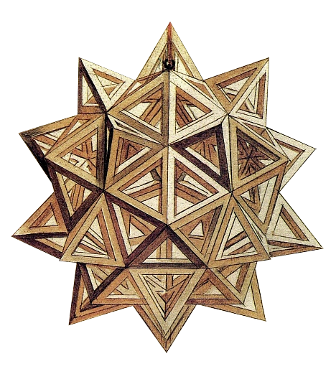

Big Apple Academy Mathematics Department
August-  5 6  Average  Monday 27 | Permutations  Combinations  Tuesday 28 | Probability  Wednesday 29 | Operations with integers  Thursday 30 | Equation  Friday 31 | expression  Saturday 1 | Incoming  6th Grade
Exponent  Base  Power  3 | Order of operation  4 | Coordinate plane  Ordered pair  Quadrant  Origin  5 | Relation  Function  6 | t-table  linear equation  7 | Angle  Acute angle  Obtuse angle  Right angle  Straight angle  8 | Summer Home Work VOCABULARY
Complementary angles  Supplementary angles  10 | Reflex angle  11 | Triangle  Classify the triangles by sides and angles  12 | Sum of all angles of a triangle  13 | Perimeter  Square  Rectangle  14 | Area  Rectangle  Perimeter  15
trapezoid  parallelogram  rhombus  square  rectangle  17 | Similar triangles  Corresponding sides  18 | Perimeter  Area  19 | Parallelogram  Area  Perimeter  20 | Surface area  Area of a square  21 | Circle  Radius  diameter  Circumference  22
Area of a circle  24 | Volume  Rectangular prism  Base  Height  25 | Mean  Median  Mode  Range  26 | Review  27

Big Apple Academy Mathematics Department
August-  5 6  3² + (–5)² – (–1)³ = ?  Monday 27 | Marcy’s average score on four tests was 84. Three of scores were 84, 88, and 80. What was the fourth score?  Tuesday 28 | Eight children line up at the water fountain. Find the number of possible arrangements.  Wednesday 29 | Find the probability of getting a sum of 5 or a sum of 7 when two cubes are tossed.  Thursday 30 | Solve  x + (–21) = –59  Friday 31 | Evaluate  x – (–2)  for x = 3  Saturday 1 | Incoming  6th Grade
Compare  –7² and (–7)²  3 | $$\frac{{-5}^{2}+{(-5)}^{2}}{\left|4^{2}- 2^{5}\right|-(-3)}$$  4 | Draw a coordinate plane. Graph and label the points given.  (0,5), (–3,1), (–1,0) (–4, –5)  5 | Tell whether relation is a function  a 1 6 9 1  b 3 -1 -1 3  6 | Make a T-table. Then graph each equation.  Y = -3  Y = – x –3  X = – 4  7 | From midnight to noon, the hands of a clock form straight angles several times. How many times?  8 | Summer Home Work for FUN
Find the complement and supplement of 56° angle.  10 | Draw a 255° angle.  11 | Is it possible to make an equilateral obtuse triangle? Explain.  12 | Find the third angle of a triangle, given that the first two angles are 55° and 70°. What kind of triangle is it?  13 | Find the area of the square which has the same perimeter as a rectangle 12 by 2.  14 | What is the greatest area of a rectangle with a perimeter of 50?  15
True or false.  All trapezoids are parallelograms.  Every square is a rhombus.  Every rectangle is a square.  17 | 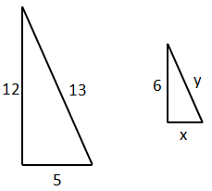  x =  y =  18 | 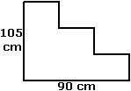  Find the perimeter and the area.  19 | 15cm  10 cm  20cm  Area = ?  Perimeter = ?  20 | Find the surface area of a cube with edge of 3.2 meters.  21 | If circumference of a Ferris wheel is 134 meters, what is its diameter? Use 3.14 for π.  22
What is the area of a circular garden with a diameter of 4 feet?  24 | An aquarium has a rectangular base 36 in by 12 in. its volume is 6912 in³. Find its height.  25 | Find the mean, median, mode and range of a data set.  1.8, 1.95, 1.85, 1.8, 1.6  26 | Check everything you solved and prepare your questions for teacher.  27

